Distributed Shared Variables:
There are two types of “distributed shared variables”,
- Broadcast variables
- Accumulators

Broadcast Variables:
Broadcast variables are used to save the copy of data across all nodes. This variable is cached on all the machines and not sent on machines with tasks. 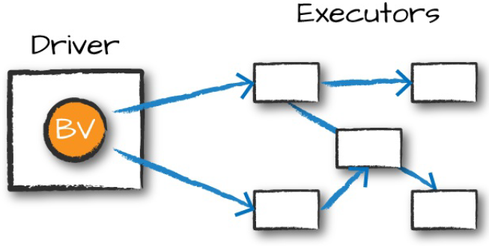
Example:
Suppose that you have a list of words or values:

There is a lookup data like below. Consider that we want to perform a join between primary data and lookup data.

Lookup data is small in size. We can fit this data in memory of all executors and can avoid sending data to every single task.
This will be very efficient.

After Broadcast variable creation, we can access its value using 'value' method.

We can use broadcasted value in other operations like below
Accumulators:
- Accumulators are a way of updating a value inside of a variety of transformations and propagating that value to the driver node in an efficient and fault-tolerant way.
- Accumulators provide a mutable variable that a Spark cluster can safely update on a per-row basis.
- You can use them to implement counters (as in MapReduce) or sums.
- Without accumulators, each worker has its own local copy of the variables in your application. This could lead to unexpected results if you are trying to aggregate data from all of the workers, such as counting the number of failed records processed across the cluster.


Example:

